VIETNAM NATIONAL UNIVERSITY – HO CHI MINH CITY
THE INTERNATIONAL UNIVERSITY
SCHOOL OF COMPUTER SCIENCE AND ENGINEERING


ONLINE TOEIC TEST
Advisor: Dr. Nguyen Thi Thuy Loan
Student name: Nguyen Duy Vinh

A thesis submitted to the School of Computer Science and Engineering in partial fulfillment of the requirements for the degree of
Bachelor of Engineering

Ho Chi Minh city, Vietnam 2020

APPROVED BY: ADVISOR APPROVED BY: COMMITTEE

Dr. Nguyen Thi Thuy Loan

Thesis committee

ACKNOWLEGMENTS
First, I appreciate all lecturers who taught me and dedicate for the excellent program I went through the six years in this university, especially all lecturers and staffs in the Computer of Science and Engineering department. All of you was teaching me a lot and pushed me become more mature. These things will help me in the rest of my life.
Second, I would like to thank Dr. Nguyen Van Sinh who taught me many lectures in these years and distribute for our school to become strong these days.
Finally, I would like to thank my adviser Dr. Nguyen Thi Thuy Loan who directly help me to complete this thesis. Her support and encouragement gave me more motivation and belief to finish this thesis.

TABLE OF CONTENTS
ACKNOWLEGMENTS 3
TABLE OF CONTENTS 4
LIST OF TABLES 7
ABSTRACT 8
1. CHAPTER 1: INTRODUCTION 9
1.1. Background 9
1.2. Problem Statement 9
1.3. Scope and Objectives 9
1.4. Assumption and Solution 9
1.5. Structure of thesis 10
1.5.1. Chapter 1: Introduction 10
1.5.2. Chapter 2: Literature review and related work 10
1.5.3. Chapter 3: Implementation 10
1.5.4. Chapter 4: Implement and Result 10
1.5.5. Chapter 5: Discussion and Evaluation 10
1.5.6. Chapter 6: Conclusion And Future Work 10
2. CHAPTER 2: LITURATURE REVIEW AND RELATED WORK 11
2.1. Overview of Online TOEIC Test 11
2.2. Online TOEIC Test in the market. 11
2.2.1. Toeic123.vn 11
2.2.2. Toeic24.vn 12
2.3. TOEIC format. 13
2.4. TOEIC test shuffle ablility. 14
2.5. Overview applied technique 15
2.5.1. HTML 15
2.5.2. CSS 15
2.5.3. Bootstrap 16
2.5.4. JavaScript 16
2.5.5. Spring Boot 16
2.5.6. RESTful API 17
2.5.7. NodeJS 18
2.5.8. VueJS 18
3. CHAPTER 3: IMPLEMENTATION 19
3.1. Functional Requirement 19
3.1.1. For Examinee: 19
3.1.2. For the admin: 19
3.2. Use case Diagram 19
3.3. Sequence diagram 21
3.3.1. Register 21
3.3.2. Login 22
3.3.3. Take tests 23
3.3.4. View achievement 24
3.3.5. CURD 25
3.4. Entity Relationship Diagram 26
3.4.1. test 26
3.4.2. part 26
3.4.3. question_group 26
3.4.4. question 27
3.4.5. Answer 27
3.4.6. User 27
3.4.7. examinee_answer 28
3.4.8. achievement 28
3.5. Entity Relationship Diagrams 29
3.6. System Architecture 30
4. CHAPTER 4: IMPLEMENT AND RESULT 31
4.1. Implementation 31
4.1.1. Front end 31
4.1.2. All Main Function 37
4.1.3. Admin management 43
5. CHAPTER 5: DISCUSSION AND EVALUATION 47
5.1. Advantages 47
5.2. Disadvantages 47
6. CHAPTER 6: CONCLUSION AND FUTURE WORK 48
6.1. Conclusion: 48
6.2. Future work: 48
REFERENCE 49

LIST OF FIGURES
Figure 3.1: Online TOEIC test use case 20
Figure 3.2: Online TOEIC register sequence diagram 21
Figure 3.3: Online TOEIC login sequence diagram 22
Figure 3.4: Online TOEIC take a test sequence diagram 23
Figure 3.5: Online TOEIC take a test sequence diagram 24
Figure 3.6: Online TOEIC CURD sequence diagram 25
Figure 3.7: ERD diagram 29
Figure 3.8: System architecture diagram 30
Figure 4.1: Examinee front-end structure 31
Figure 4.2: App.vue 32
Figure 4.4: Router.js 32
Figure 4.5: Test.vue 34
Figure 4.6: Part.vue 34
Figure 4.7: Admin front-end structure 35
Figure 4.8: App.vue 36
Figure 4.9: Router.js 36
Figure 4.10: Login 37
Figure 4.11: Sign up 38
Figure 4.12: Home page 39
Figure 4.13: Test page 40
Figure 4.14: Result page 41
Figure 4.15: Achievement page 42
Figure 4.16: Admin homepage 43
Figure 4.17: Test editor 44
Figure 4.18: Part editor 45
Figure 4.19: Question editor 46

LIST OF TABLES
Table 2.1: Toeic123.vn advantages and disadvantages 11
Table 2.2: Toeic24.vn advantages and disadvantages 12
Table 2.3: TOEIC format detail for this thesis 13
Table 2.4: Shuffle ability of a TOEIC test. 14
Table 3.1: User Requirements 19
Table 3.2: Test database table 26
Table 3.3: Part database table 26
Table 3.4: Question group database table 26
Table 3.5: Question database table 27
Table 3.6: Answer database table 27
Table 3.7: User database table 27
Table 3.8: Examinee answers database table 28
Table 3.9: Achievement database table 28

ABSTRACT

English is an international Language so that nowadays learning English became an essential subject for everyone to communicate and study aboard. There are many testing systems that was built to evaluate ability in English of people like IELTS, TOFLE, and TOEIC. It is costly every time anyone who take a test, so it is necessary that there are some websites contain mock tests to help students trying before their real tests. This kind of websites also support English teachers in class or teaching online.
In this thesis, I developed and website for people to take some TOEIC test on it. This website will contain several TOEIC test and there are some other functions like shuffle each tests each time to make more versions of them and it could help them taking the test more efficiently.

CHAPTER 1: INTRODUCTION

Background
Testing online and taking test on electronic device is becoming more popular nowadays
because of it is more convenient and saving. Firstly, there is no need to use paper
anymore that help reduce using resources. Secondly, it is quicker and more correct to
mark many tests.
So that an Online TOEIC Test website can be applied for testing online and for every
English center, classes to take test quicker and more conveniently.

Problem Statement
Nowadays, a few websites basically provided ability to take a TOEIC test for everyone,
But most of them still simple and display the same test for any people that means
questions and answers are showed still the same with all people. This website needs to
inherit their function but add an ability to shuffle questions and answers.

Scope and Objectives
The purpose of this thesis is developing a website where anyone can take an TOEIC test
and then get there result as soon as possible. The administrator can create, read, update,
and delete its content. The administrator can also view examinee information and their
achievement. Moreover, each time someone take a test, a version of this test will be
created by shuffle its questions and answer.

Assumption and Solution
- A single page website should be created by VueJS that is a JavaScript Framework support to create a single page website. Its user interface (UI) is developed by HTML, CSS library that is Bootstrap, and some JavaScript implements.
- All is managed by MySQL and others file format for image and audio are contained on a server by NodeJS.
- In the back end I use Spring Boot that will communicate with front-end by API service.

Structure of thesis

Chapter 1: Introduction
An overview of the formation process of this project as well as the technologies used throughout the dissertation development process. Readers will get an overview first before digging deeper through the rest of this thesis report.

Chapter 2: Literature review and related work
Review the specific job requirements here as the TOEIC test. All the context of the job is given to explain the reason for forming this graduation project. Furthermore, assessing the existing products on the market by giving the advantages and disadvantages of each product thus creating a reasonable direction for this project. In addition, give the structure of a TOEIC test and based on that structure, build the most appropriate and optimal feature possible. Finally, present all the technologies that will be applied to this product.

Chapter 3: Implementation
Product design by drawing user requirements to summarize all user actions that can be taken in this project and describe the process of user interaction with the system. From the 2 elements on the data should be listed and design the relationship between them. Finally, the structure of the system needs to be designed to show the interaction between the components and their technology.

Chapter 4: Implement and Result
Product specific representation on the programming environment, the structure of web pages and the programming files of the description and some representative photographs of the main functional files will be given.

Chapter 5: Discussion and Evaluation
The main content of this section is to evaluate the overall graduation thesis by offering its advantages and disadvantages then comparing with the representative products in the market.

Chapter 6: Conclusion And Future Work
The final part of the graduation thesis summarizes the content and process of the work and sets out the intentions and goals to perfect this product in the future.

CHAPTER 2: LITURATURE REVIEW AND RELATED WORK

Overview of Online TOEIC Test
- Nowadays Internet become wide applied in almost area include education. Learning online help reduce cost and effort and it is more efficient in some cases.
- Most people can teach and share their knowledge no matter how long the distances between them, everything become easy just with internet connection.
- Studying English online is becoming a trend nowadays due to its advantages. There are some ways to process teaching online like use available video sharing website like YouTube and a huge of websites developed to serve the need of the market.
- Most of them may provide a part of people need but some more function should be developed to customize learning online.

Online TOEIC Test in the market.
Most of websites today have provided basic functions for clients to take some TOEIC test on them but some of them are still not enough function and have friendly user interface. After that, I would like to overview some available website that is widely used in Vietnam.

Toeic123.vn
Table 2.1: Toeic123.vn advantages and disadvantages
Advantages | Disadvantages
- Its data of test is quite numerous.  - Student can select doing a part or the whole test. | - The user interface is so messy, It is not really friendly.  - Single page technique is not applied so that user have to scroll for long during the test in only one page.

Toeic24.vn
Table 2.2: Toeic24.vn advantages and disadvantages
Advantages | Disadvantages
- Its user interface quite beautiful and clear.  - The instructions of each parts are really helpful to makesure examinee understand clearly what is going to do on this each tests. | - Audio file is divided to each parts so that user have to click play each times they take the test. That is not similar to the real test where an audio is just started one time during the whole listening test.  - Single page technique is not applied so that they divide the test to many parts and student cannot review what they just have done if they have moved to the next part.

TOEIC format.
- TOEIC inclule 2 skill is Reading and Listening that is devided to 7 parts with 4 listening parts and 3 reading parts.
Table 2.3: TOEIC format detail for this thesis
Part | Type | No of Questions | Details
Part 1 | Listening | 10 | There is an image each question. The answers are read from audio file.
Part 2 | Listening | 30 | The question and answer are read from audio file, examinee just select answers (A, B, C, D).
Part 3 | Listening | 30 | A short conversation for each 3 questions, the questions and answers are printed on the tests.
Part 4 | Listening | 30 | A short speech for each 3 questions, the questions and answers are printed on the tests.
Part 5 | Reading | 30 | Separated questions and answer is printed on this paper.
Part 6 | Reading | 16 | 4 Groups of 4 questions, each group have a text with 4 blanks to fill correspond to 4 questions.
Part 7 | Reading | 54 | Number of group question from 3-5 question each group with an essay.

TOEIC test shuffle ablility.
Suffle ability give client two advantages:
- First, limit reminder when anyone want to try a test again.
- In case schools or classes want to hold an exam with many people, so that they need each people have different version of an exam to avoid cheating.
Note: Not all questions and answer can be shuffled due to its characteristic, all listening question cannot be shuffled because they depend on the audio, or in part six of reading the question indexes is on the reading passage so that they cannot be changed.
Table 2.4: Shuffle ability of a TOEIC test.
Part | Group | Shuffled Group | Answer Id | Shuffled Question | Shuffled answer
Part 1 | NO | - | NO | NO | NO
Part 2 | NO | - | NO | NO | NO
Part 3 | NO | - | YES | NO | YES
Part 4 | NO | - | YES | NO | YES
Part 5 | NO | - | YES | YES | YES
Part 6 | YES | NO | YES | NO | YES
Part 7 | YES | YES | YES | YES | YES

Overview applied technique

HTML
- HTML stands for Hypertext Markup Language. It helps users create and structure elements of web pages or applications, divide paragraphs, headings, links, blockquotes, and so on.

- HTML is not a programming language, meaning it cannot create "dynamic" functions. It is just like Microsoft Word, used to layout and format web pages.

- When working with HTML, we will use a simple code structure (tags and attributes) to mark up a webpage. For example, we can create a paragraph by putting text inside a pair of tags that open and close the text <p> and </p>

- <p> This is how you add paragraphs in HTML. </p>
<p> You can add more paragraphs! </p>

- In general, HTML is a markup language, it is easy to understand, easy to learn, and every new person can start learning it to build a website. Here is what you will learn in this article:

CSS
- CSS is the style language for websites - Cascading Style Sheet language. It is used to style and style elements that are written in markup languages, such as HTML. It can control the format of multiple websites at the same time to save effort for web writers. It distinguishes the look of a web page from its main content by controlling the layout, colors, and fonts.
- CSS was developed by W3C (World Wide Web Consortium) in 1996, for a simple reason. HTML is not designed for tagging to help format web pages. You can only use it to "bookmark" the site.
- Tags like <font> were released in HTML version 3.2, which caused a lot of trouble for programmers. Because the website has many different fonts, background colors and different styles. To rewrite code for a website is a long, arduous process. Therefore, the CSS generated by the W3C is to solve this problem.
- The relationship between HTML and CSS is strong. HTML is the markup language (the foundation of the site) and CSS shapes the style (everything that makes up the website interface), they are inseparable.
- CSS theoretically does not have, but then the website will not just be a page containing text but nothing else.

Bootstrap
- Bootstrap is a framework of HTML, CSS and JavaScript templates used to develop responsive website standards. Bootstrap allows website design process to take place more quickly and easily based on the basic elements available such as typography, forms, buttons, tables, grids, navigation, image carousels, etc. What are the benefits for Bootstrap developers?
- Bootstrap is a free collection of open source and tools used to create a complete website template. With pre-defined interface properties such as size, color, height, width ..., designers can create many new products but still save time when working with this framework. Website interface design process.

JavaScript
- JavaScript is a scripting language that enables you to create dynamically updating content, control multimedia, animate images, and pretty much everything else. (Okay, not everything, but it is amazing what you can achieve with a few lines of JavaScript code.)

Spring Boot
- Spring boot is a prominent project in the Spring Framework ecosystem, the fastest way to create an independent REST service. Spring boot simplifies configuration, namely, Spring Boot configures itself all by providing specific behaviors. It simplifies deploying, by packaging our app into a jar package, so it can be easily integrated into web containers. Previously, creating a Spring project was quite difficult, from declaring dependencies in pom.xml to configuring with XML or complex annotations, now with Spring Boot we can create Spring application is quick and simple to configure.
- Benefits of Spring Boot:
  - Easy to develop Spring based applications with Java or Groovy
  - Minimize development time and increase productivity
  - It avoids having to write a lot of boilerplate codes, annotations, and XML configurations.
  - It is easy for you to interact with Spring Boot applications with Spring ecosystems such as Spring JDBC, Spring ORM, Spring Data, Spring Security etc.
  - It follows the "Default Configuration Principle" approach to minimize the time and effort required to develop applications.
  - It provides Embedded HTTP servers such as Tomcat, Jetty, etc. to develop and test web applications quickly and easily.
  - It provides CLI (Command Line Interface) tool to develop and test Spring Boot applications (Java or Groovy) from the command line (command prompt) very easily and quickly.
  - It provides a lot of plugins to develop and test Spring Boot applications quickly using Build tools like Maven and Gradle.
  - It provides many plugins to work with embedded databases and in-memory Databases easily.

RESTful API
- REST (Representational State Transfer) was first introduced in 2000 in the doctoral thesis of Roy Thomas Fielding (co-founder of the HTTP protocol). In the dissertation, he introduced in detail the constraints, conventions as well as how to perform with the system to get a REST system. Put simply, REST is a system of constraints, just making sure your system can be called RESTful.
- REST defines architectural rules for you to design Web services, focus on system resources, including how resource states are formatted and transmitted over HTTP, and written in multiple languages. different.
- REST has a simple architecture, defining constraints to create Web services applications that achieve the desired properties of performance, scalability, scalability, etc.
- REST aims to build a Web service application that works best on the WWW environment.
- Data and features are treated as resources and are accessed through URIs (Uniform Resource Identifier).
- REST uses four main methods of HTTP, POST, GET, PUT, and DELETE, to perform CRUD actions on resources.
- The RESTful API is a standard used in the design of API designs. Web services are often applied REST structures to build.
- The basic structure of the REST structure:
  - Use HTTP methods explicitly
  - Stateless
  - Show directory structure as URLs
  - Transmit JavaScript Object Notation (JSON), XML or both

NodeJS
- Nodejs is an independent development platform built on Chrome's JavaScript Runtime that we can build network applications quickly and easily.
- Nodejs was built and developed in 2009, sponsored by Joyent, based in California, USA. Anyway, we should know a little bit of the history of what we're learning a little bit, right?
- The lower part of the Nodejs Core is written mostly in C ++ so the processing speed and performance are quite high.
- Nodejs creates applications with fast processing speed, real time real time.
- Nodejs applies to products that have a lot of traffic, need to expand quickly, need to innovate technology, or create Startup projects as quickly as possible.

VueJS
- According to the homepage of Vue.js. VueJS is a JS Framework used to build the user interface. Vue is designed from the beginning to allow and encourage application development step by step ... Can meet the needs of SPA (Single-Page Applications).

- Unlike monolithic frameworks, Vue is designed from the ground up to allow and encourage application development step by step. When developing a view layer, users only need to use Vue's core library, which is very easy to learn and integrate with existing libraries or projects. At the same time, if combined with modern technologies such as SFC (single file components) and supporting libraries, Vue also easily meets the needs of building single-page applications (SPA - Single-Page Applications).) with greater complexity.

CHAPTER 3: IMPLEMENTATION

Functional Requirement

For Examinee:
- Take a TOEIC test include 200 question in 7 Part by choosing a Test on the website.
- Question and answer will be shuffled as much as possible each time anyone chooses the test.
- Mark the tests and save their achievement after each test is taken.
- Login, register and review their achievement.

For the admin:
- Add, edit, delete the tests and their group questions, questions, and answers.
- View examinee Information and their achievement

Use case Diagram
Table 3.5: User Requirements
Examinee | Administration
- Register to be a member to take test on the website.  - Login the website if they are members already and Logout to login by another account or stop using the website.  - Take tests after login the website, users can choose any tests that are contained on the website and do it any time. The audio will automatically run just after they agree to take any test and this audio cannot be stopped until the end.  - View their achievements after taking any tests before. The test will be loaded and show all these questions and answers they did before. | - Create new test by a friendly user interface, that allow the administration to add fully tests to the database.  - Read data of all test to check.  - Update all data if the administration discovers mistakes or just want to modify for reasons.  - Delete fully tests of a part of them to reduce or change test library.  - Login to start working and logout to stop working.  - View student achievements.

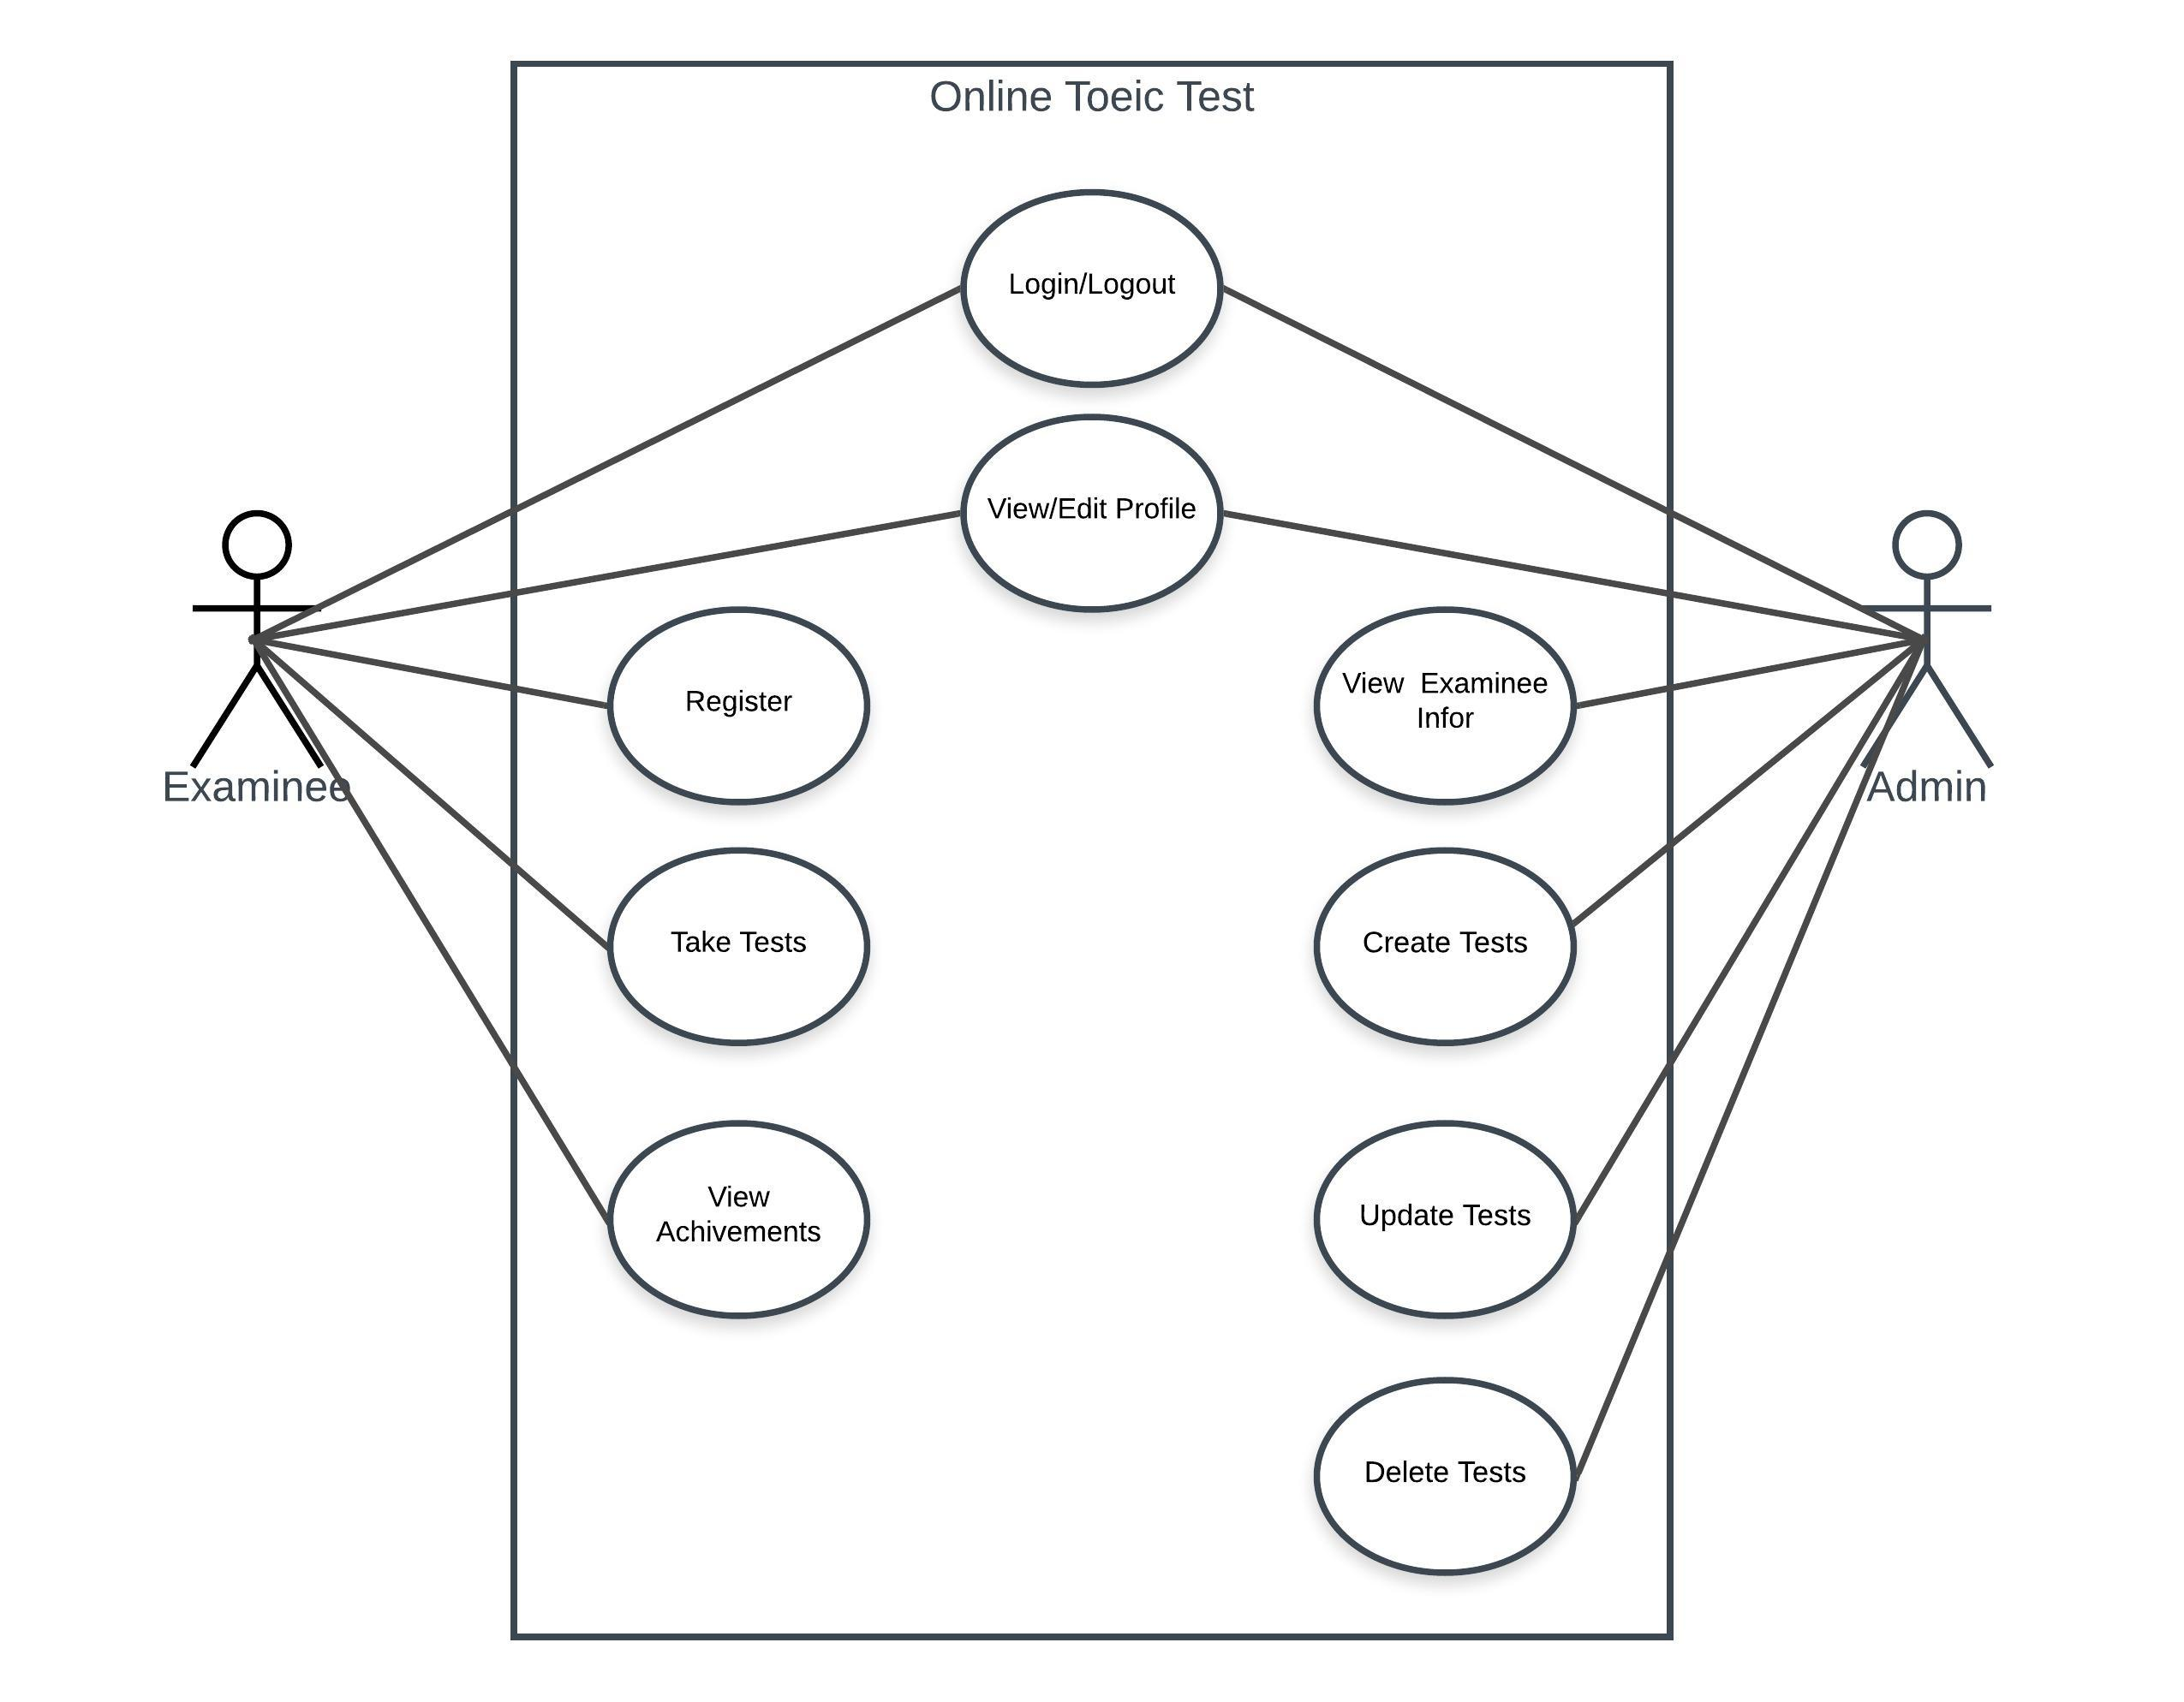
Figure 3.1: Online TOEIC test use case

Sequence diagram

Register
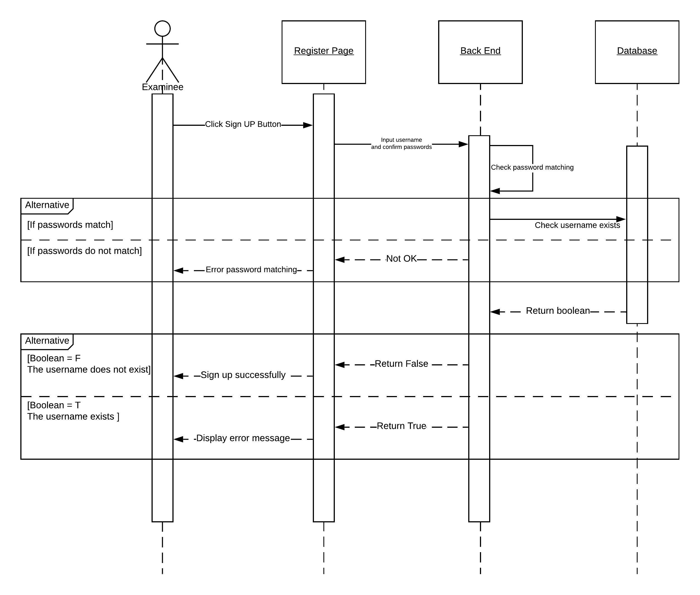
Figure 3.2: Online TOEIC register sequence diagram

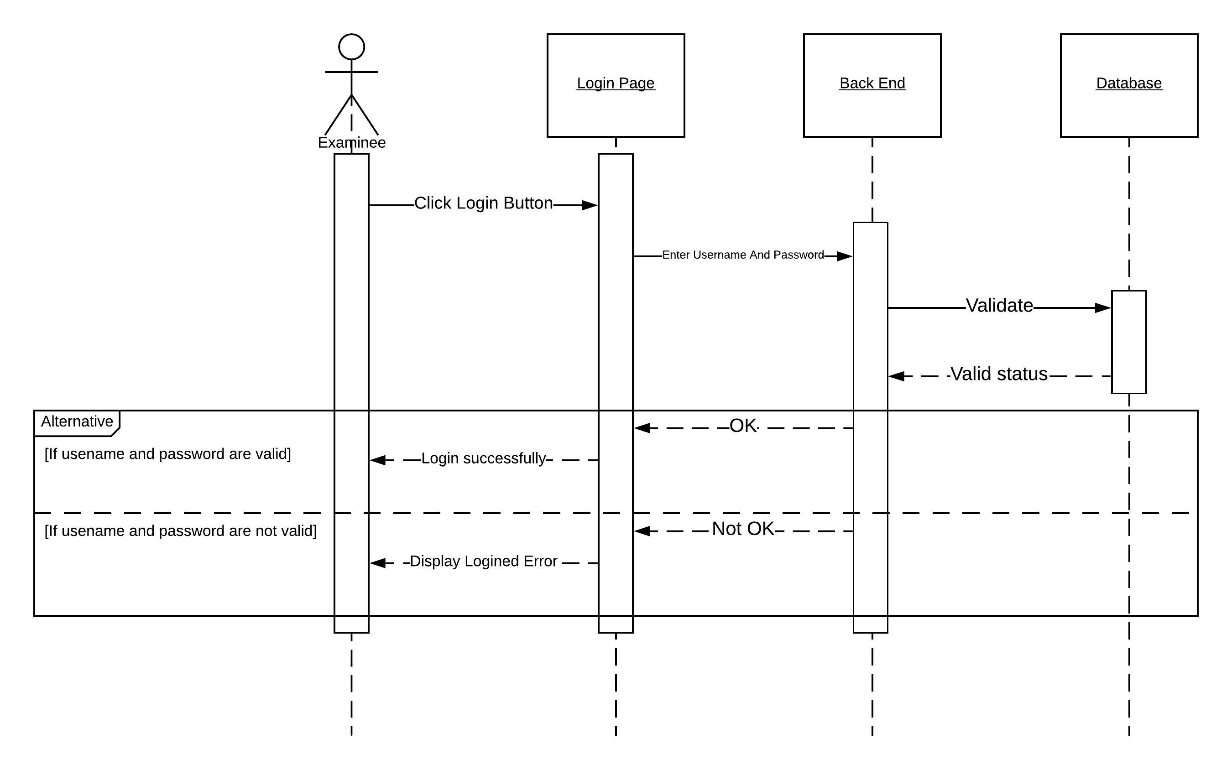
Login
Figure 3.3: Online TOEIC login sequence diagram

Take tests
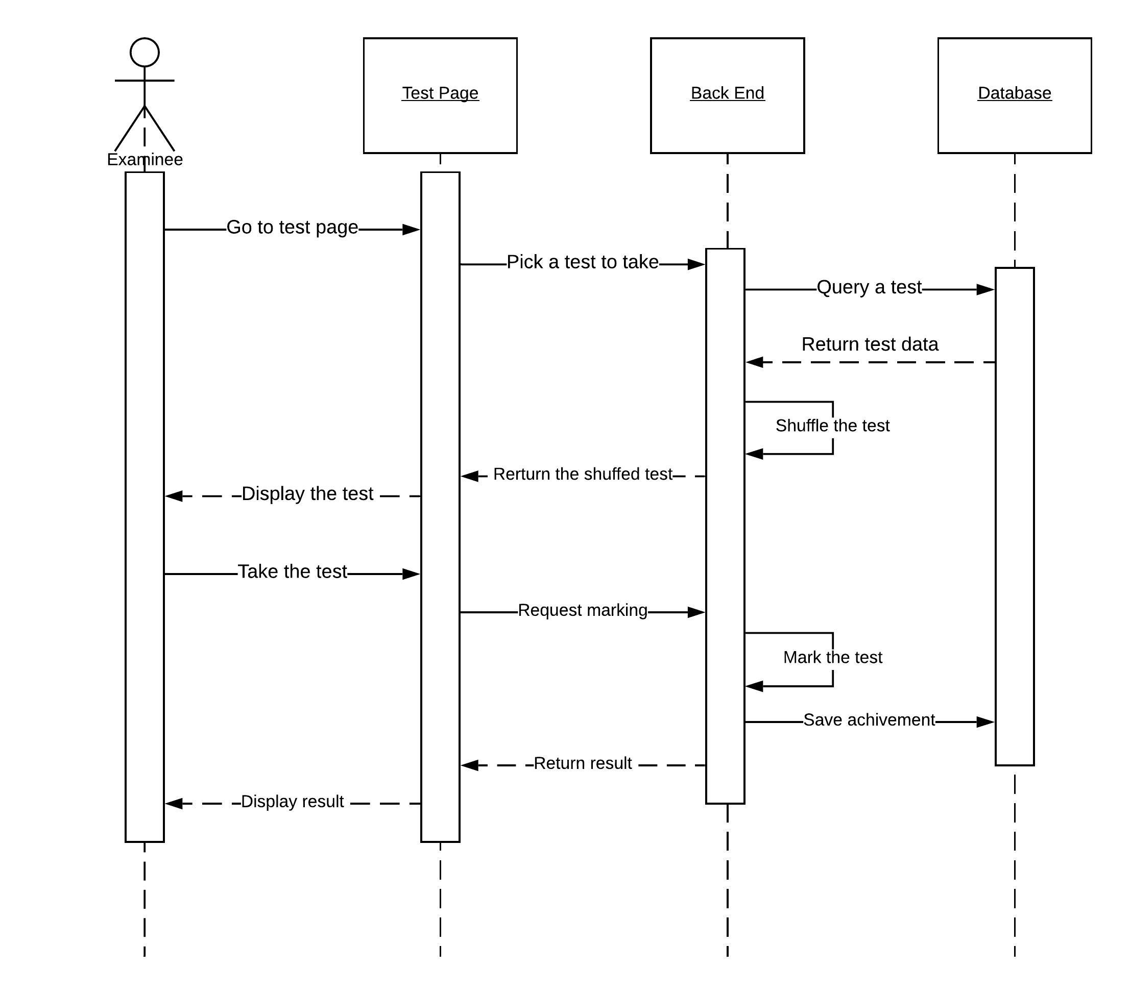
Figure 3.4: Online TOEIC take a test sequence diagram

View achievement
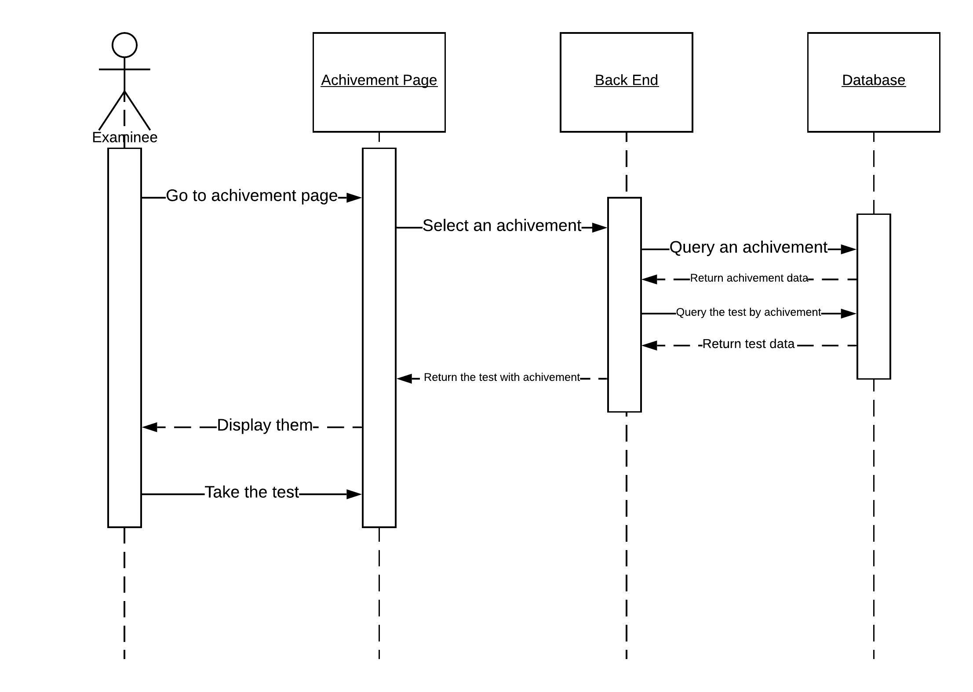
Figure 3.5: Online TOEIC take a test sequence diagram

CURD
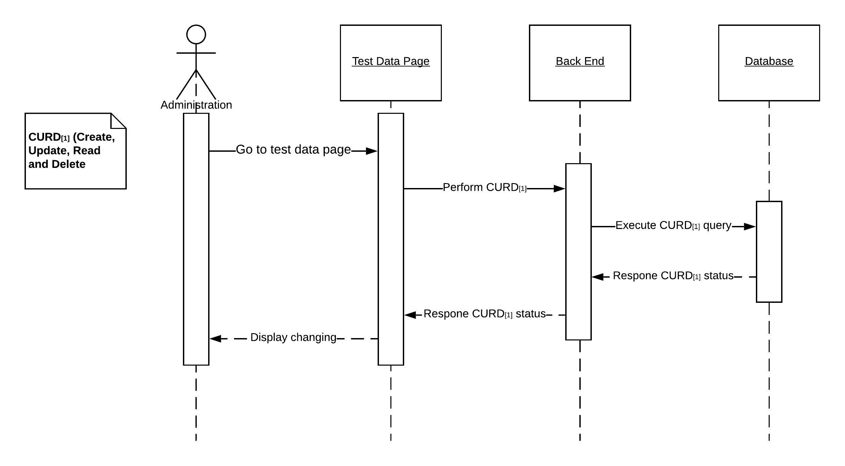
Figure 3.6: Online TOEIC CURD sequence diagram

Entity Relationship Diagram

test
Table 3.6: Test database table
STT | Attribute Name | Data Types | Null | Note
1 | id | int(11) | No | AUTO_INCREMENT
2 | test_name | varchar(255) | No
3 | audio_link | varchar(255) | No

part
Table 3.7: Part database table
STT | Attribute Name | Data Types | Null | Comment
1 | id | int(11) | No | AUTO_INCREMENT
2 | test_id | int(11) | No
3 | part_num | int(11) | No
4 | type | int(11) | No
5 | title | varchar(255) | No
6 | direction | longtext | No

question_group
Table 3.8: Question group database table
STT | Attribute Name | Data Types | Null | Comment
1 | id | int(11) | No | AUTO_INCREMENT
2 | index | int(11) | Yes
3 | title | varchar(255) | Yes
4 | part_id | int(11) | No
5 | image_link | varchar(255) | Yes
6 | paragraph | longtext | Yes

question
Table 3.9: Question database table
STT | Attribute Name | Data Types | Null | Comment
1 | id | int(11) | No | AUTO_INCREMENT
2 | index | int(11) | Yes
3 | part_id | int(11) | Yes
4 | group_id | int(11) | No
5 | image_link | varchar(255) | Yes
6 | question_title | longtext | Yes
7 | correct_answer | char(1) | Yes
8 | correct_answer_id | int(11) | Yes

Answer
Table 3.10: Answer database table
STT | Attribute Name | Data Types | Null | Comment
1 | id | int(11) | No | AUTO_INCREMENT
2 | question_id | int(11) | No
3 | content | text | No

User
Table 3.11: User database table
STT | Attribute Name | Data Types | Null | Comment
1 | id | int(11) | No | AUTO_INCREMENT
2 | email | varchar(255) | No
3 | password | varchar(255) | No
4 | name | varchar(255) | No
5 | role | int(11) | No | 1: examinee, 2: administrator

examinee_answer
Table 3.12: Examinee answers database table
STT | Attribute Name | Data Types | Null | Comment
1 | id | int(11) | No | AUTO_INCREMENT
2 | achievement_id | int(11) | No
3 | question_id | int(11) | No
4 | answer_id | int(11) | No
5 | option | char(1) | No

achievement
Table 3.13: Achievement database table
STT | Attribute Name | Data Types | Null | Comment
1 | id | int(11) | No | AUTO_INCREMENT
2 | examinee_id | int(11) | No
3 | date | varchar(255) | No
4 | test_id | int(11) | No
5 | total_correct_answer | char(1) | No

Entity Relationship Diagrams
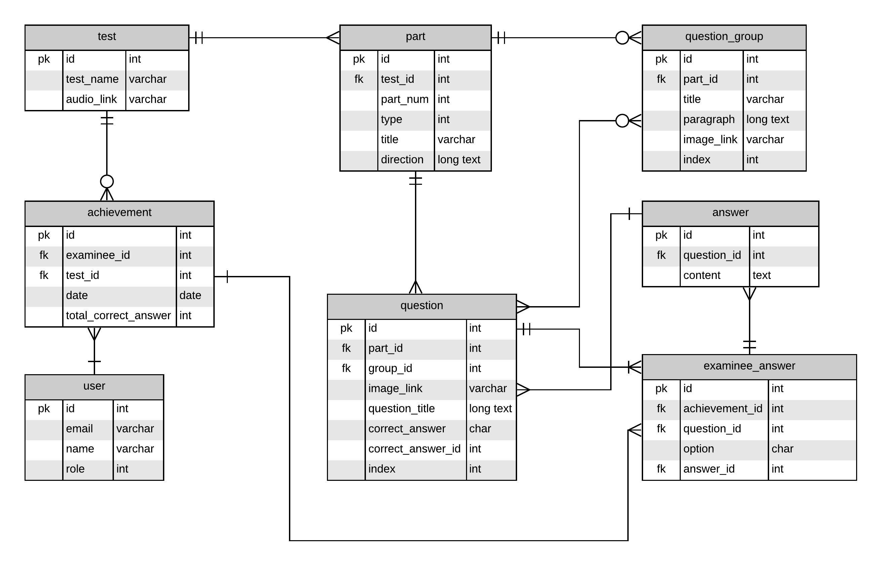
Figure 3.7: ERD diagram

System Architecture
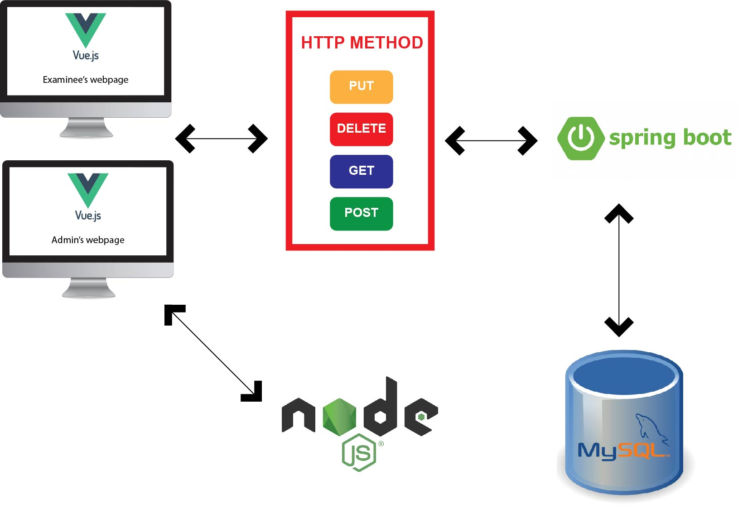
Figure 3.8: System architecture diagram
- Figure description
- Firstly, by HTTP methods are PUT, DELETE, GET and POST front end application by VueJS included admin’s and examinee’s web application request API service from back end that developed by Spring boot.
- Back end after that handle logic code and load database by my MySQL command.
- Node JS hear is applied to create a file server that contain audios and images and return a URL for front end to use.

CHAPTER 4: IMPLEMENT AND RESULT

Implementation

Front end

Examinee
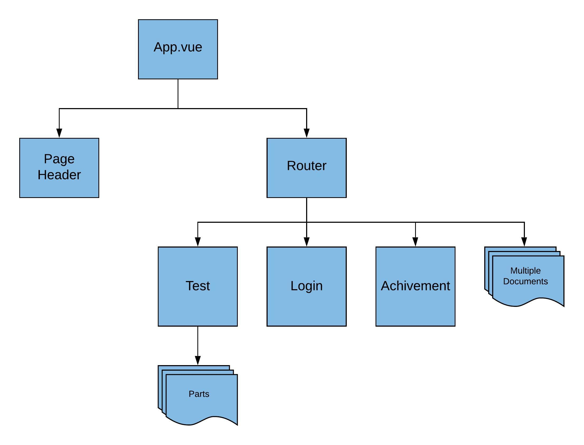
Figure 4.9: Examinee front-end structure
- Figure description for App.vue and router.js
- App.vue is the main of VueJS that contains the whole website, in this website it contains Page Header file in component folder and the router that link to different websites supported by VueJS.
- Router link to different pages by its URL configured on the router.js, the parameter is attached on the URL.
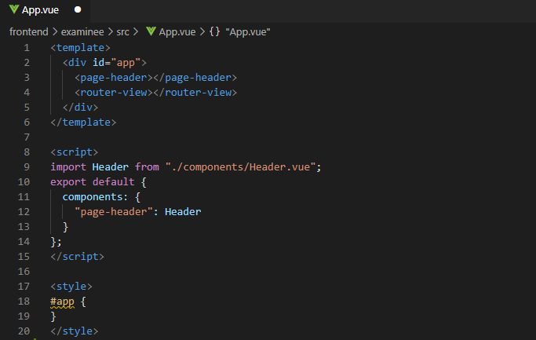
Figure 4.10: App.vue

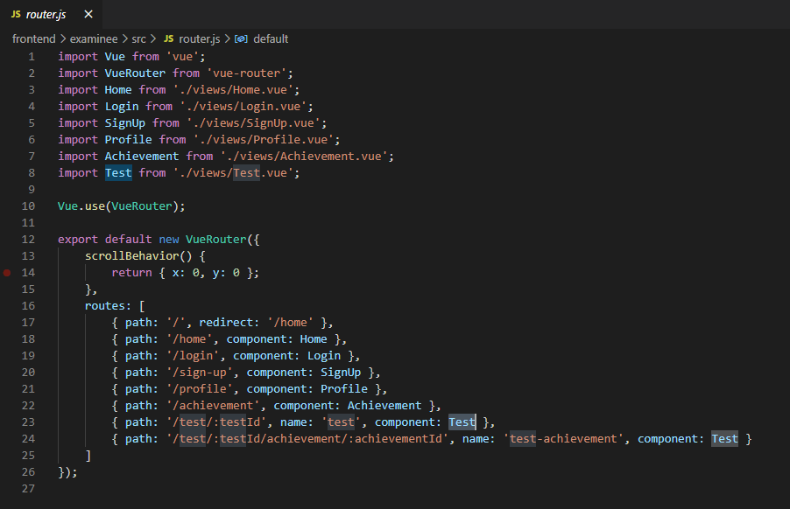
Figure 4.11: Router.js

- Figure description for Test.vue and Part.js
- Line 14-22 in Test.vue <keep-alive> tag keep all input or option choosing remain when any router change, v-if function mean that if the condition is satisfy this code affect to the page, if not the code inside will not effect on this page.
- In part.vue, data from is loaded by object partdata, all question group and question will be load by 2 for loops from line 14 to line 28.
- Question in Part.js is also a page in component folder, to be simpler and keep the file short that need to be divided into many components.
- Parameters are attached on the URL that provide information for back end to retrieve data.
- V-for and v-if are VueJS function that affect only if the conditions are satisfy.

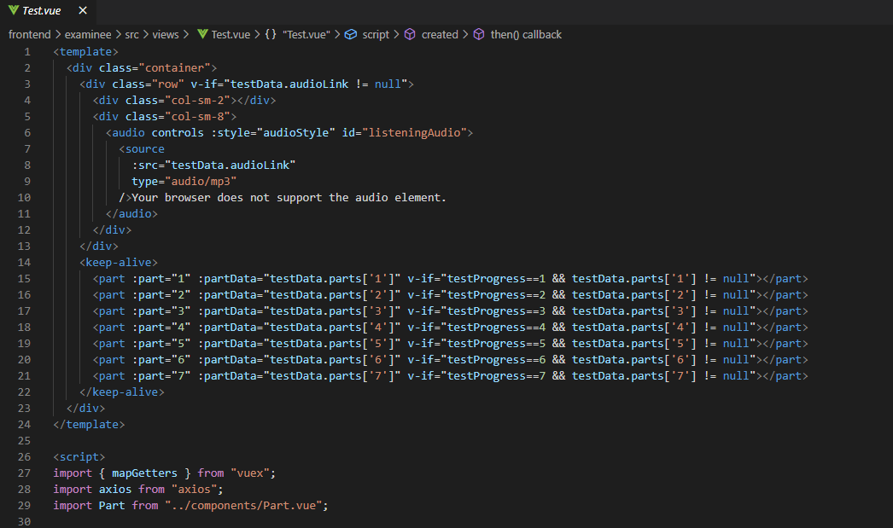
Figure 4.12: Test.vue

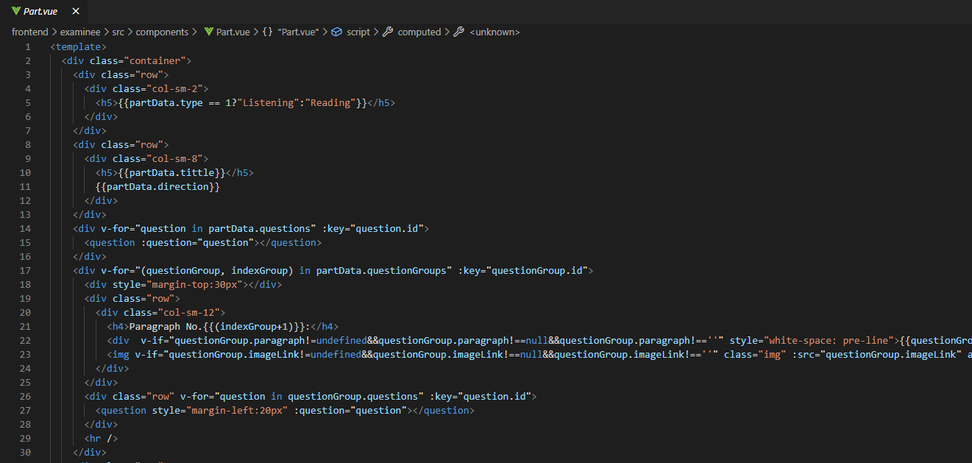
Figure 4.13: Part.vue

Admin
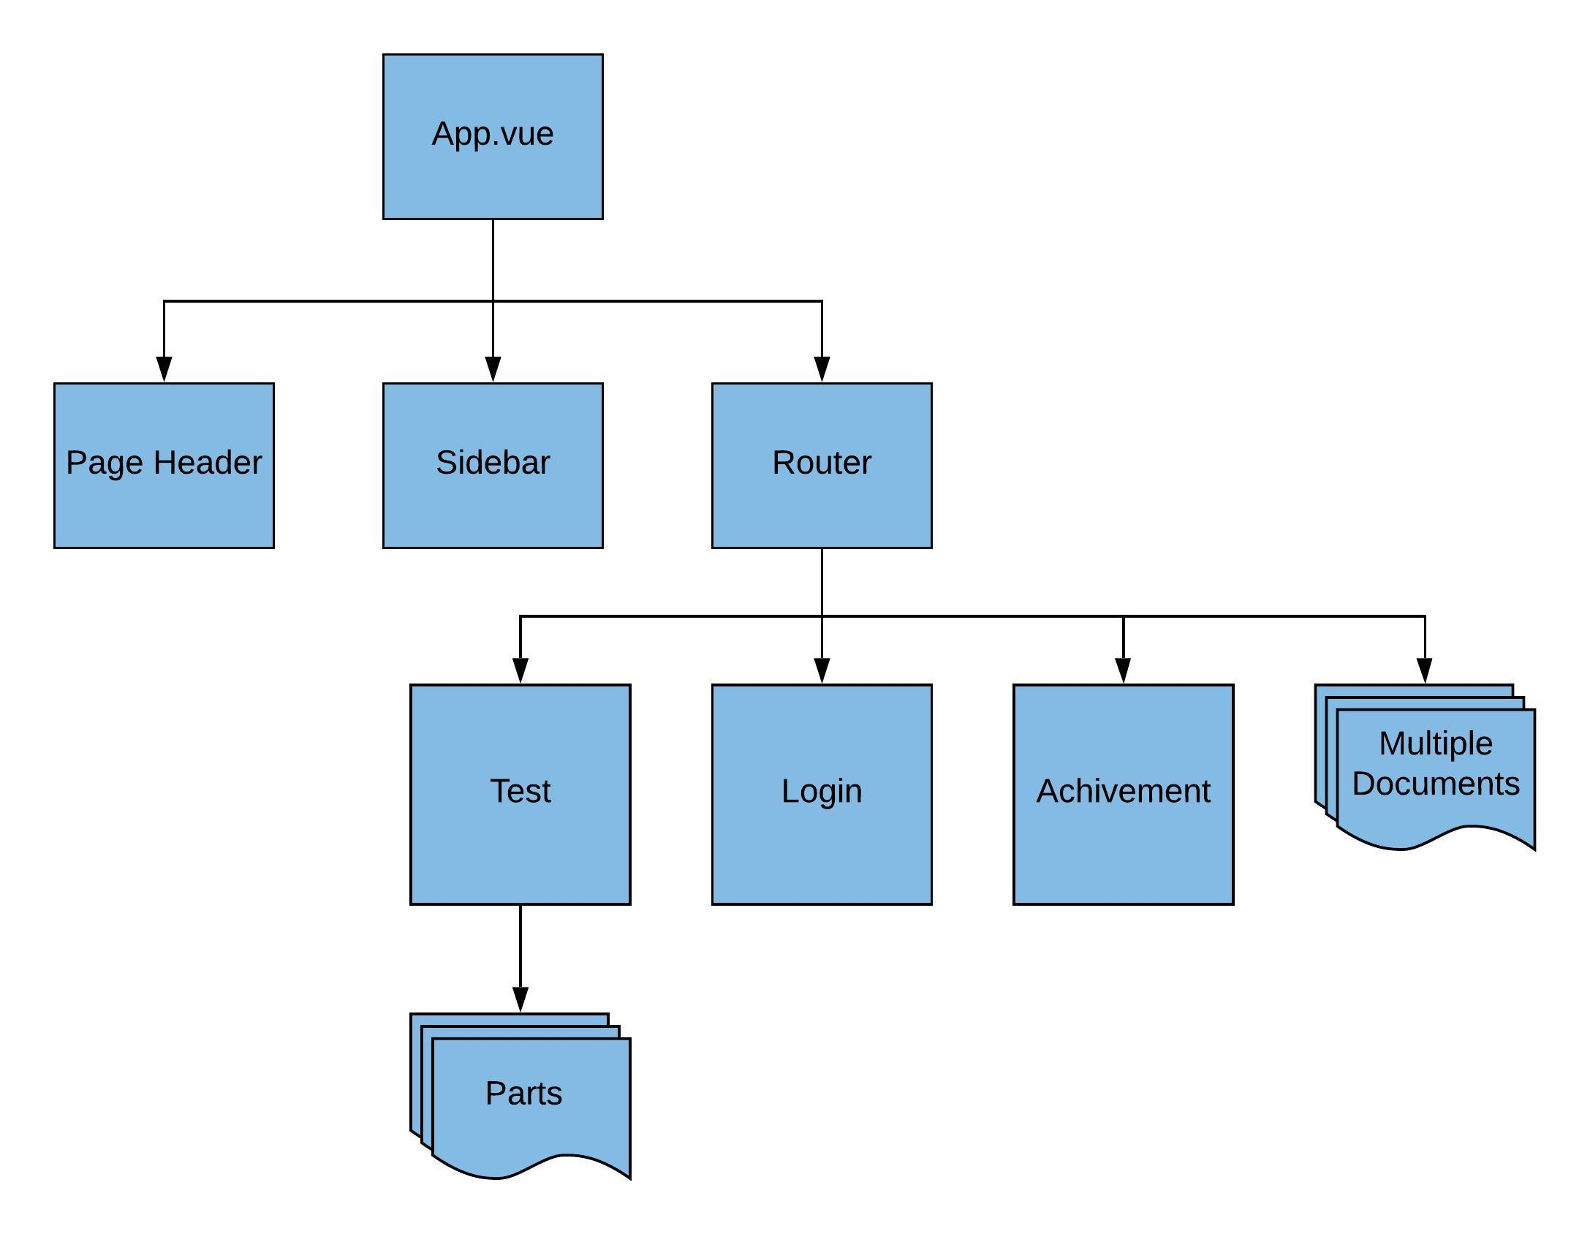
Figure 4.14: Admin front-end structure
- Figure description for App.vue and Router.js
- This App.vue is the main file of the admin webpages that contains the whole websites. Firstly, the sidebar is the menu of this admin website, that contain button directing to main function of this app. Secondly, the page header contains status of login of the admin. Finally, the router view that link to other pages that perform kinds of functions like create, update, and delete.
- Parameters are used to provide data for the back end to process data.
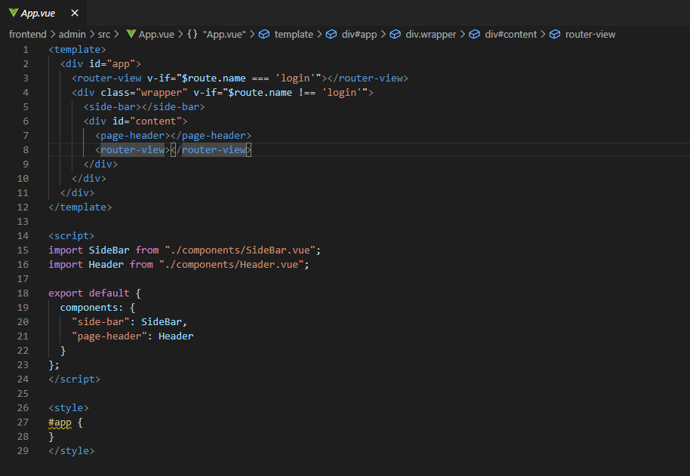
Figure 4.15: App.vue

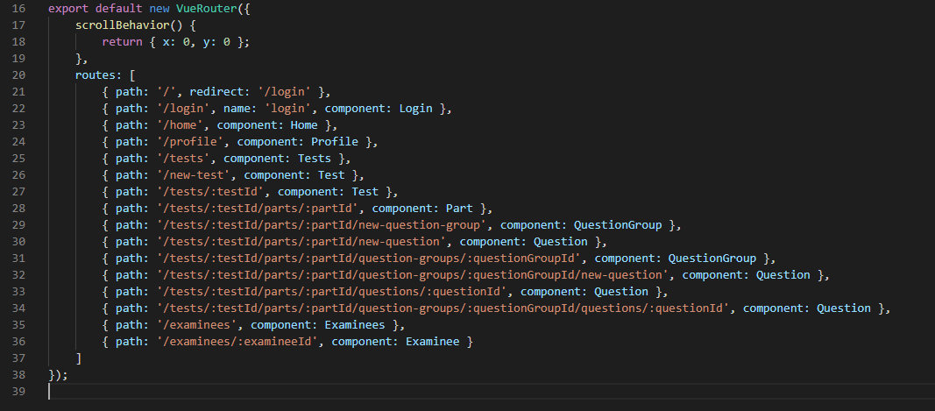
Figure 4.16: Router.js

All Main Function

Login and sign up
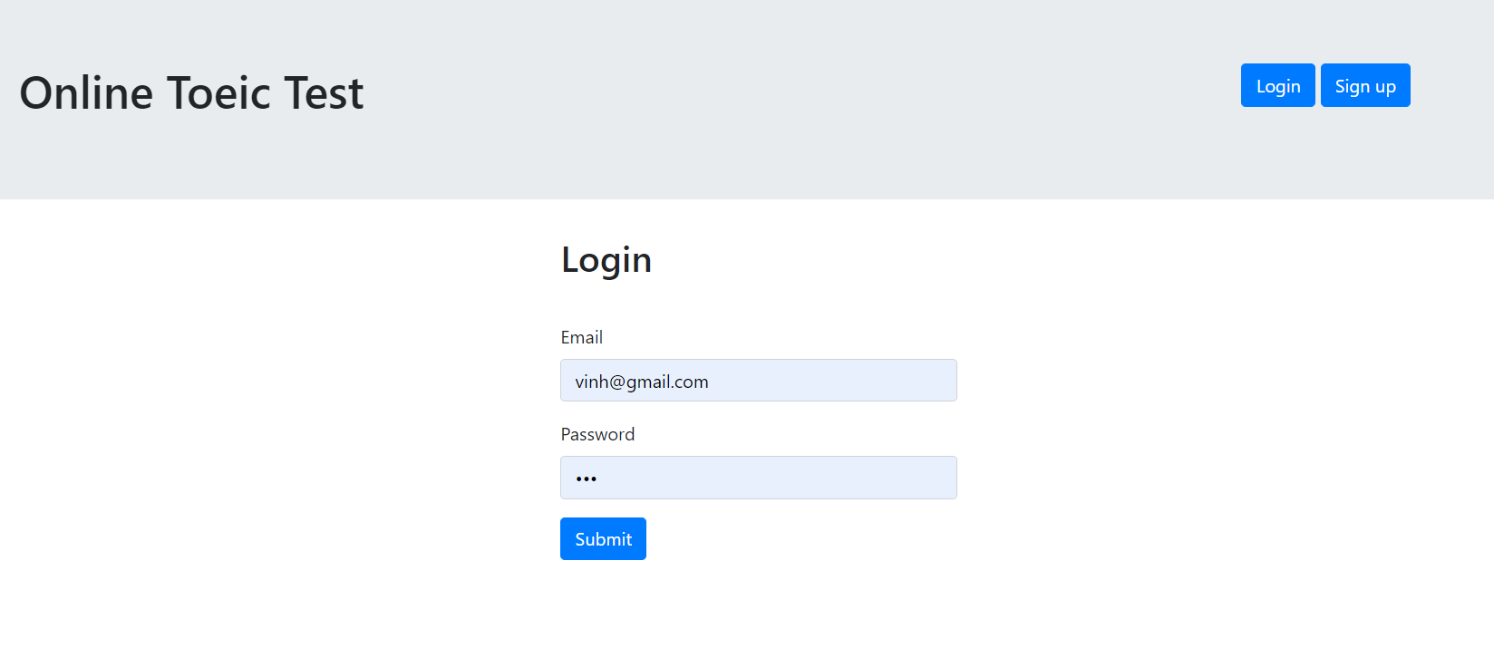
Figure 4.17: Login
- Description of login
- If the users have not logged in to the website, it direct to the login page automatically, the users need to have an account to log in, if not they need to sign up one.
- The email used as username is imputed with the password to login this website before taking any test.
- After login, this site will be move to the home page where user can take a test if the username and password are not fit, some different errors will be showed.

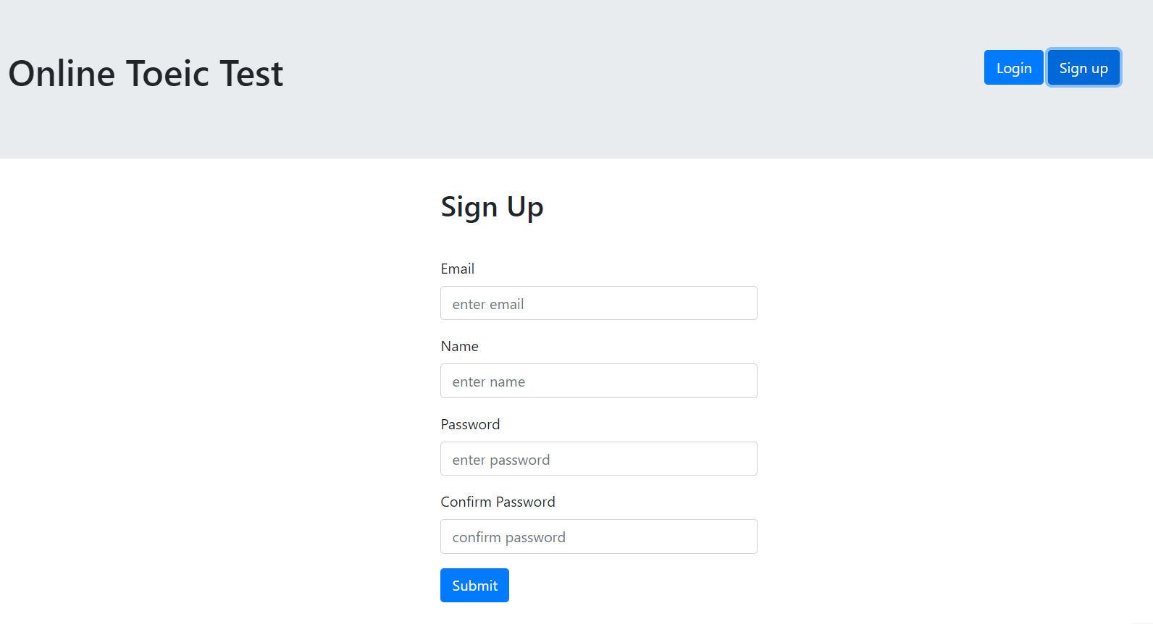
Figure 4.18: Sign up
- Description of sign up
- The users use any email that is not exist in the database to create a new account, if the email exists an error will be throwed.
- The name that will be display on header after the user log in the website.
- In the password and confirm password input, two passwords must be the same to each other. If they are different an error will be throwed.
- When user click submit button, this site change state to logged in and direct to home page.

Examinees take test process.
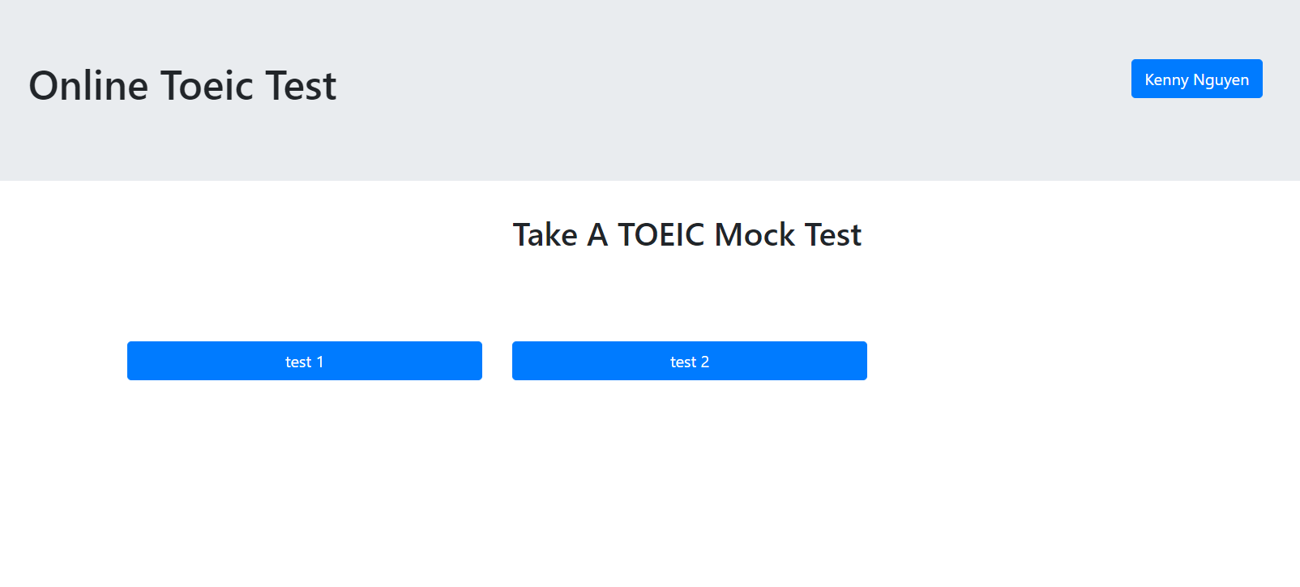
Figure 4.19: Home page

- Description of home page
- The home page include header with the logo and username button that link to the profile page.
- On the body a list of tests is shown, and user can select a test to take, the test page will show after clicking.
- The list of tests is loaded by three tests in a row.

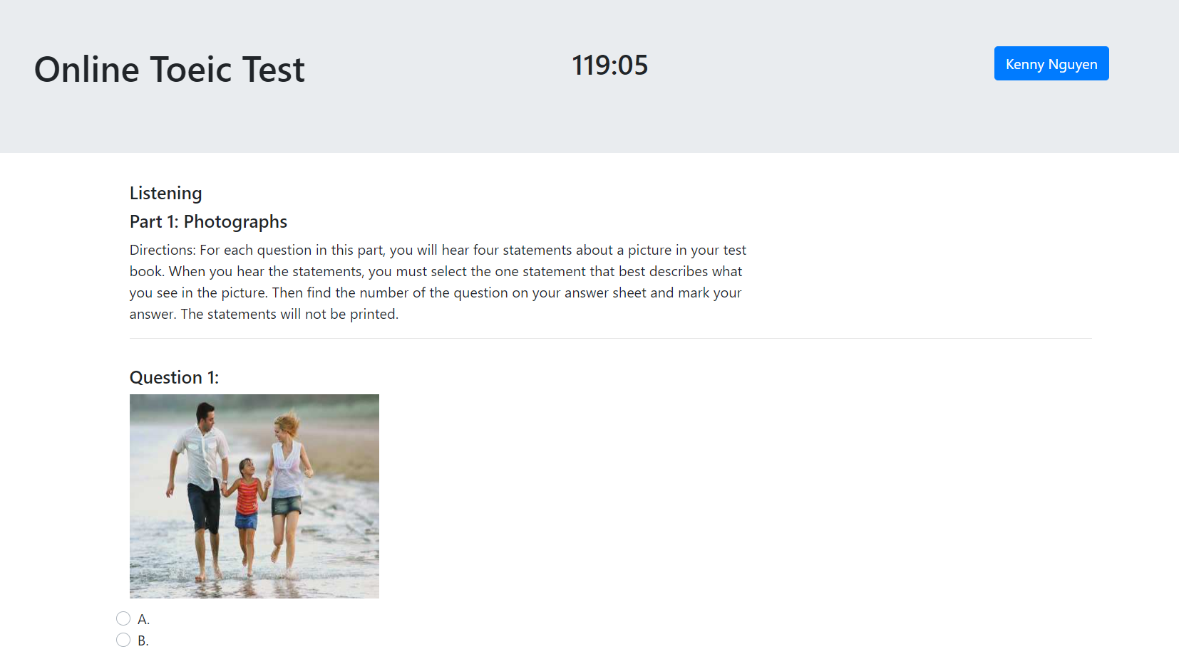
Figure 4.20: Test page

- Description of test page
- At the time user click to take the test, the audio will run automatically according to the real TOEIC test. The fist part of the test is shown first.
- The user takes the test by listening and choose the answer at the same time, they click next and previous button to move to next and previous part of the test and change the answer anytime they want to do.
- The test will end any time they submit or try to go out of the test, the result will return and save after they submit the test.

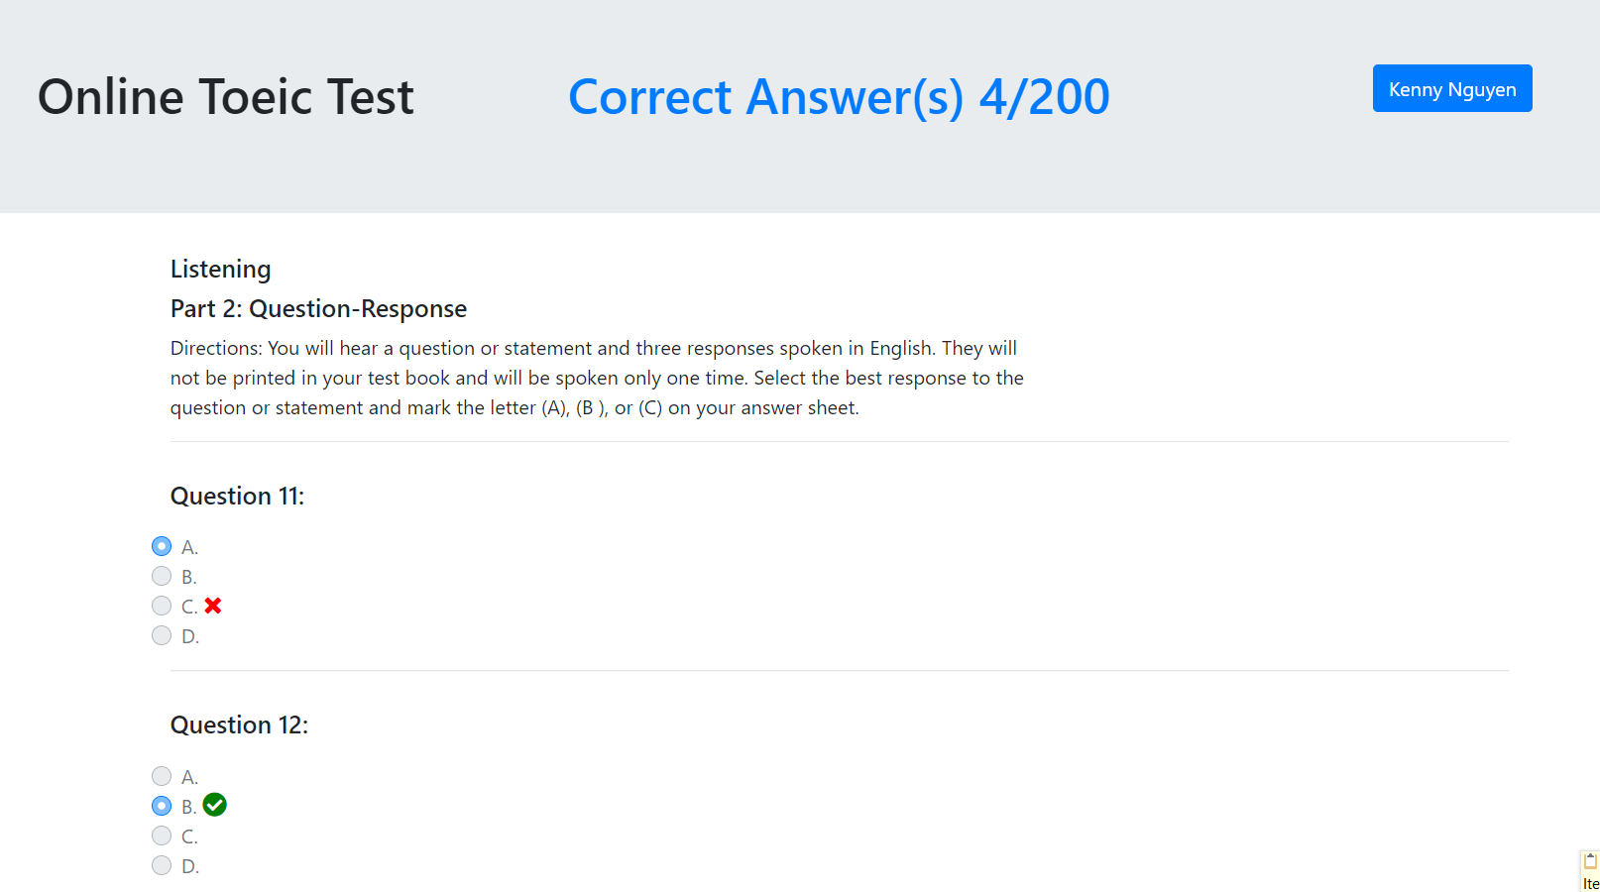
Figure 4.21: Result page

- Description of result page
- After submitting the test, the whole test page will be loaded including the result.
- Each question the user will know what the correct and wrong answers are by cross and tick icon beside each answer.
- The total correct answer will be shown on the header right the place the play time display when users take the test.
- All the test will be saved on the achievement for each user.

View Achievement
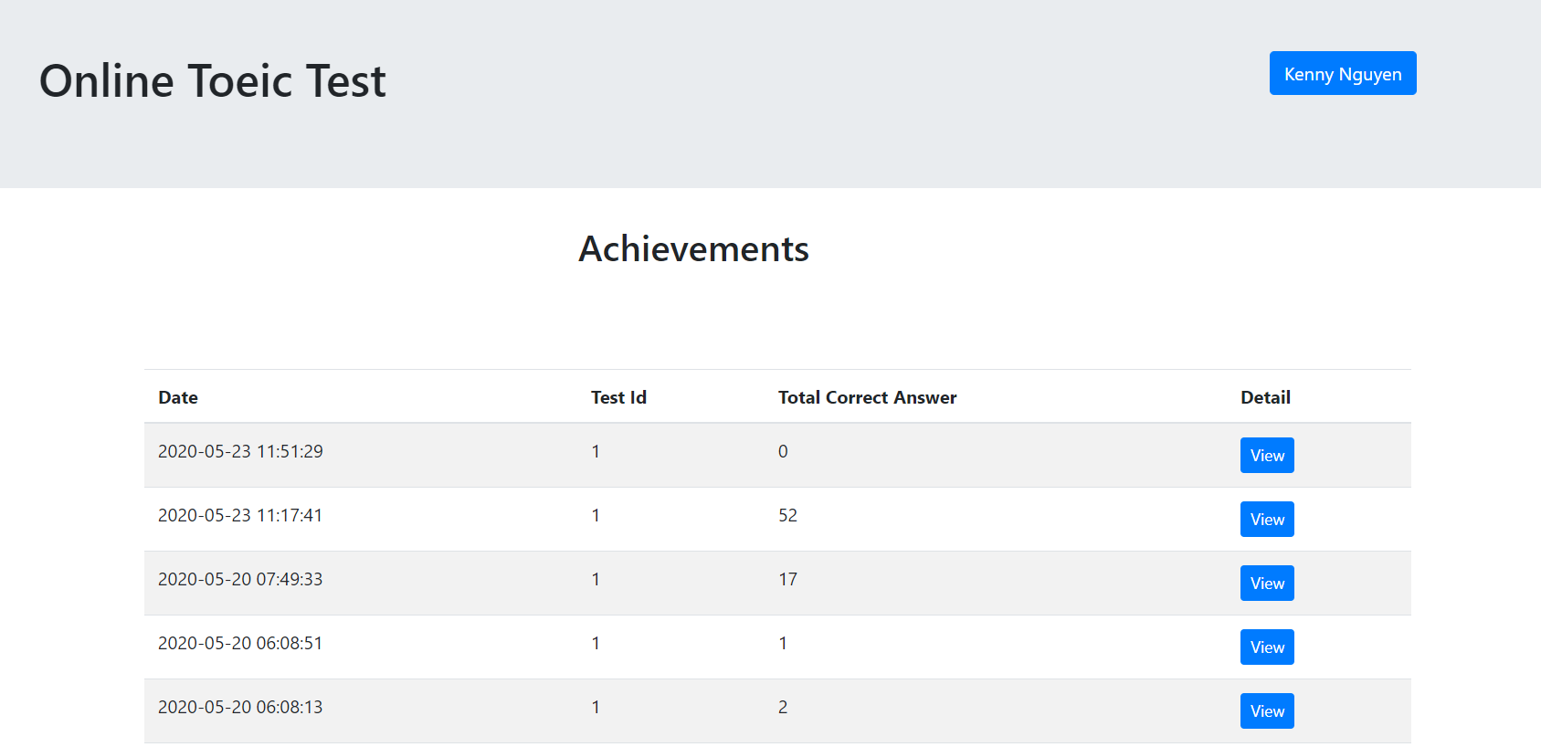
Figure 4.22: Achievement page
- Description of achievement page
- In the achievement page a table with 4 field are dates generated by the system, test id of the test, total correct and answer and detail of the test.
- When users click button view to get the detail of the test mean the test result page will be load again. The questions and answer will be load but the position can be changed because only correct answer id according to the database is saved in achievement.

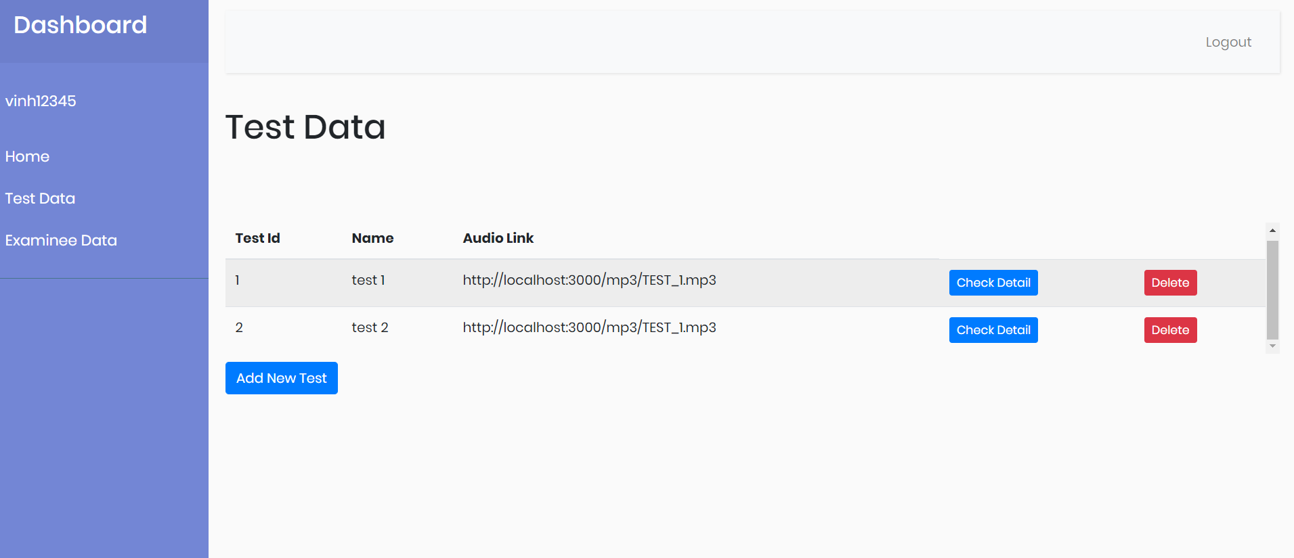
Admin management
Figure 4.23: Admin homepage
- Description of admin homepage
- In the default page of test data all test will be show on a table where the admin can delete the whole test or go into their detail.
- The audio link is also shown here but if the admin wants to edit it he or her must check detail.
- At the bottom, there is a button to add new whole test, whenever a new whole test is created this test will initial default format from test number 1.

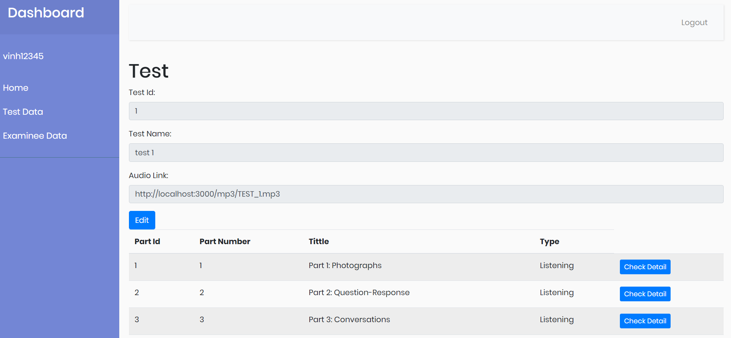
Figure 4.24: Test editor
- Description of test editor page
- In the test editor page admin will see content corresponding with the test includes test id, test name, and audio link but when the edit activated only test name and audio link can be changed.
- In addition, a list of part will be shown with 7 parts with part number and their titles.
- To do more with test the admin can click check detail to go into each part, the admin can also go back the test default page to do another test.
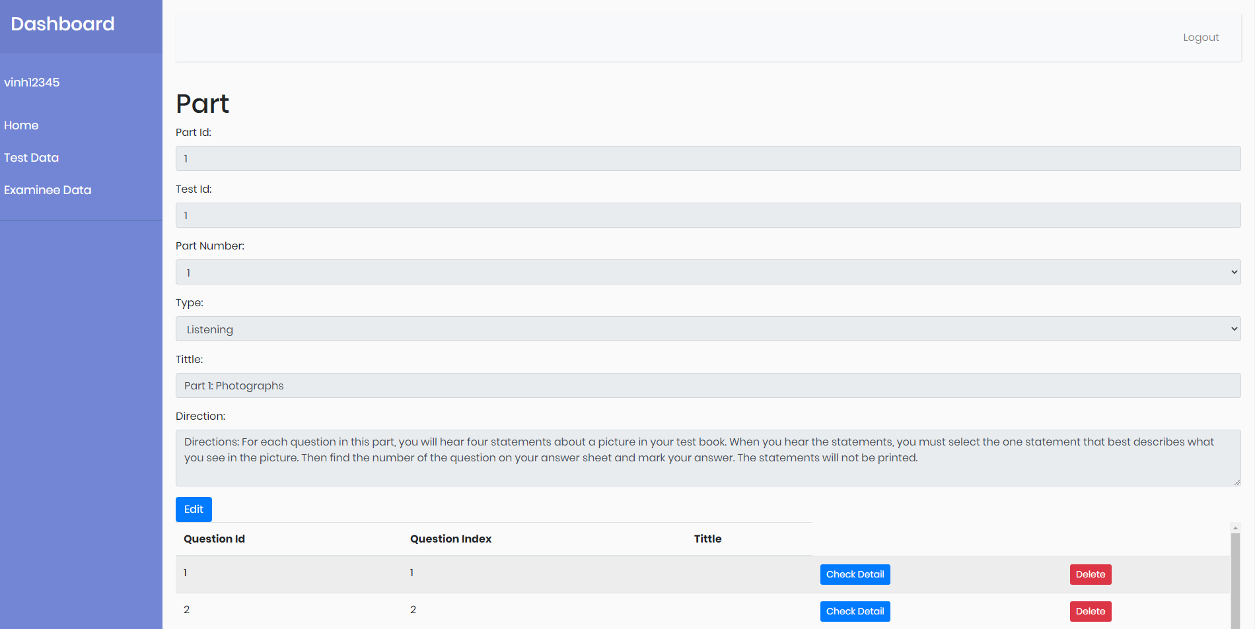
Figure 4.25: Part editor
- Description of part editor page
- In the part editor page, all information corresponding with the part will be shown and the admin can edit the title and direction of this part.
- Below the information a table that shows a list of question where the admin can delete any questions or click check detail button to go into the detail of them.
- A question can be added by the button “Add New Question” below the question list.
- The admin can go back to the previous interface.

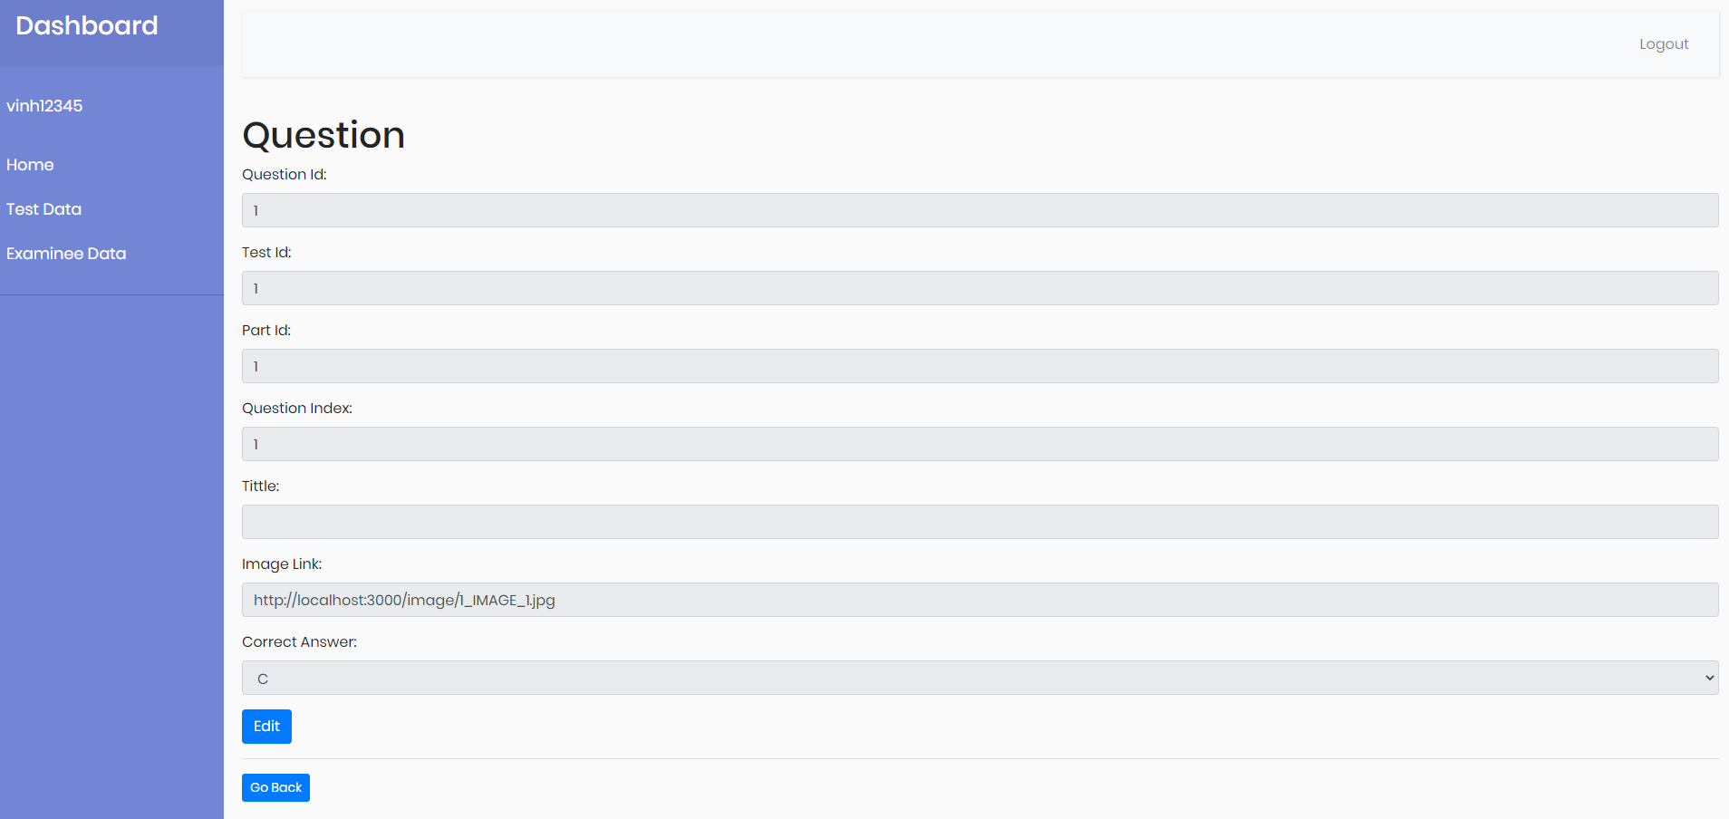
Figure 4.26: Question editor
- Description of part editor page
- The further page is the question page where the admin can change information of the answer including the tittles and image links.
- In addition, the admin can edit the content of all answers of every questions and select what the correct answers are.

CHAPTER 5: DISCUSSION AND EVALUATION

Advantages
- This site basically meets the basic needs for a TOEIC listening and writing test.
- It is presented by single page application that help the test is processed continuously that most website in the market have not applied.
- By using nearly newest techniques, the website works separately between front end, back end, and data server.
- Admin and examinee user interface quite friendly and simple that will save time for user to be used to with it.

Disadvantages
- The number of features of this website still incomplete, some features for speaking and writing that need to be added because only reading and listening are not enough for an English testing website.
- Although the user experiment of this website is quite good, but the user interface is too simple that need to be more luxury and beautiful that would be more professional.
- Because of my ability, some questions, group question and part cannot be shuffled. For example, in the listening test all questions are kept on their positions.

CHAPTER 6: CONCLUSION AND FUTURE WORK

Conclusion:
- Learning English is a very big need in non-native English-speaking countries like Vietnam. So that, the websites that support English test will be developed more in the future. An ideal website could help provide a various feature for testing not only reading and listening but also speaking and writing that can be apply artificial intelligence that can determine the sound and grammar effectively.
- In this thesis, the need to have a website to take a test online are responded.

Future work:
- In the future, if this thesis will be used officially, some features that should be developed:
  - Support writing and speaking test
  - Improve the user interface to be more professional
  - Combine with an English center or another English organization that will create more value by that combination.
  - Apply new technology like artificial intelligence in deterring pronunciation and grammar mistakes.

REFERENCE

[1] HTML tutorial
Accessed: February 02, 2020
https://www.tutorialspoint.com/html/index.htm

[2] Bootstrap tutorial
https://getbootstrap.com/
Accessed: February 2020

[3] Spring boot tutorial
https://spring.io/projects/spring-boot
Accessed: February 2020

[4] How do I start with Node.js after I installed it?
https://nodejs.org/en/docs/guides/getting-started-guide/
Accessed: February 2020

[5] English testing website
https://www.toeic123.vn/
Accessed: February 2020

[6] TOEIC test library
https://www.anhngumshoa.com/tin-tuc/tron-bo-nbsp-125-de-thi-toeic-2019-co-dap-an-37218.html
Accessed: March 2020

[7] Spring Boot in Action by Craig Wall – Foreword by Andrew Glover
Accessed: February 2020

[8] Java How To Program – 9th Edition by Paul Deitel and Harvey Deitel
Accessed: 2015

